***LIFE EXPECTANCY; definition:***

Life expectancy is the key metric for assessing population health. Broader than the narrow metric of the [infant and child mortality](https://ourworldindata.org/child-mortality), which focus solely at mortality at a young age, life expectancy captures the mortality along the entire life course. It tells us the average age of death in a population.

Estimates suggest that in a pre-modern, poor world, life expectancy [was around 30 years](https://ourworldindata.org/life-expectancy#life-expectancy-has-improved-globally) in all regions of the world.

Life expectancy has increased rapidly since the Age of Enlightenment. In the early 19th century, life expectancy started to increase in the early industrialized countries while it stayed low in the rest of the world. This led to a very high inequality in how health was distributed across the world. Good health in the rich countries and persistently bad health in those countries that remained poor. Over the last decades this global inequality decreased. No country in the world has a lower life expectancy than the countries with the highest life expectancy in 1800. Many countries that not long ago were suffering from bad health are catching up rapidly.

Since 1900 the global average life expectancy has more than doubled and is now above 70 years. The inequality of life expectancy is still very large across and within countries. in 2019 the country with the lowest life expectancy is the Central African Republic with 53 years, in Japan life expectancy is 30 years longer.

### ***Differences in life expectancy across the world***

The world map shows the latest data published by the United Nations for life expectancy.

Life expectancy is a measure of premature death and it shows large differences in health across the world.

The population of many of the richest countries in the world have life expectancies of over 80 years. In 2019 the life expectancy in Spain, Switzerland, Italy, and Australia was over 83 years. In Japan it was the highest with close to 85 years.

In the countries with the worst health life expectancy is between 50 and 60 years. The population of the Central African Republic has the lowest life expectancy in 2019 with 53 years.

Use the slider below the map to see the change over time or click on any country to see the changing of life expectancy around the world.

OECD Data: [Life Expectancy at birth](https://ourworldindata.org/grapher/life-expectancy-at-birth-oecd)

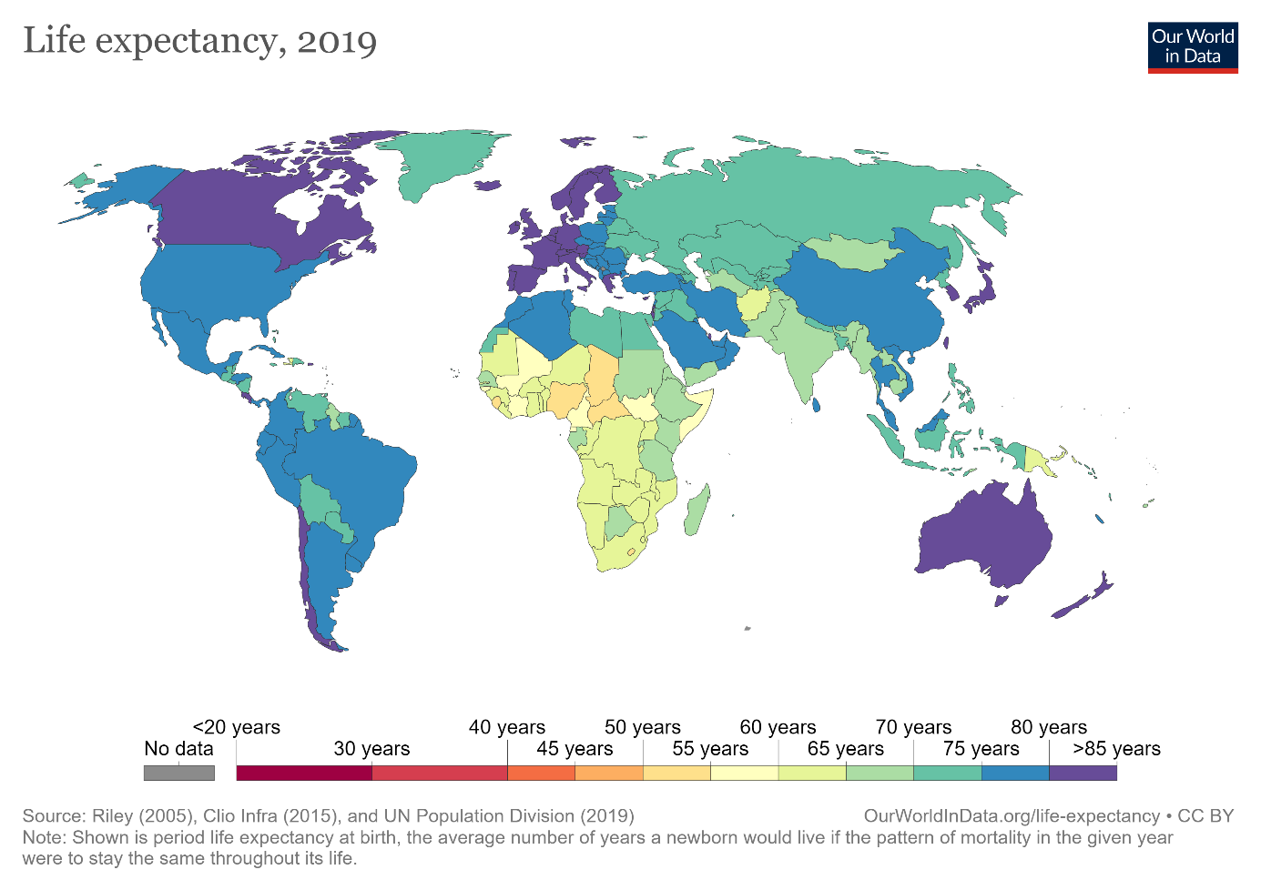

***How did life expectancy change over time?***

**Twice as long – life expectancy around the world**

The three maps show the global history of life expectancy over the last two centuries.1

Demographic research suggests that at the beginning of the 19th century no country in the world had a life expectancy longer than 40 years.2 Every country is shown in red. Almost everyone in the world lived in extreme poverty, we had very little medical knowledge, and in all countries our ancestors had to prepare for an early death.

Over the next 150 years some parts of the world achieved substantial health improvements. A global divide opened. In 1950 the life expectancy for newborns was already over 60 years in Europe, North America, Oceania, Japan and parts of South America. But elsewhere a newborn could only expect to live around 30 years. The global inequality in health was enormous in 1950: People in Norway had a life expectancy of 72 years, whilst in Mali this was 26 years. Africa as a whole had an average life expectancy of only 36 years, while people in other world regions could expect to live more than twice as long.

The decline of child mortality was important for the increase of life expectancy, but life expectancy increasing was certainly not only about falling child mortality – life expectancy increased at all ages.

Such improvements in life expectancy — despite being exclusive to particular countries — was a landmark sign of progress. It was the first time in human history that we achieved sustained improvements in health for entire populations.3 After millennia of stagnation in terrible health conditions the seal was finally broken.

Now, let’s look at the change since 1950. Many of us have not updated our world view. We still tend to think of the world as divided as it was in 1950. But in health — and many other aspects — the world has made rapid progress. Today most people in the world can expect to live as long as those in the very richest countries in 1950. The United Nations estimate a global average life expectancy of 72.6 years for 2019 – the global average today is higher than in any country back in 1950. According to the UN estimates the country with the best health in 1950 was Norway with a life expectancy of 72.3 years.

The three maps summarize the global history of life expectancy over the last two centuries: Back in 1800 a newborn baby could only expect a short life, no matter where in the world it was born. In 1950 newborns had the chance of a longer life if they were lucky enough to be born in the right place. In recent decades all regions of the world made very substantial progress, and it were those regions that were worst-off in 1950 that achieved the biggest progress since then. The divided world of 1950 has been narrowing.

Globally the life expectancy increased from less than 30 years to over 72 years; after two centuries of progress we can expect to live much more than twice as long as our ancestors. And this progress was not achieved in a few places. In every world region people today can expect to live more than twice as long.

The global inequalities in health that we see today also show that we can do much better. The almost unbelievable progress the entire world has achieved over the last two centuries should be encouragement enough for us to realize what is possible.

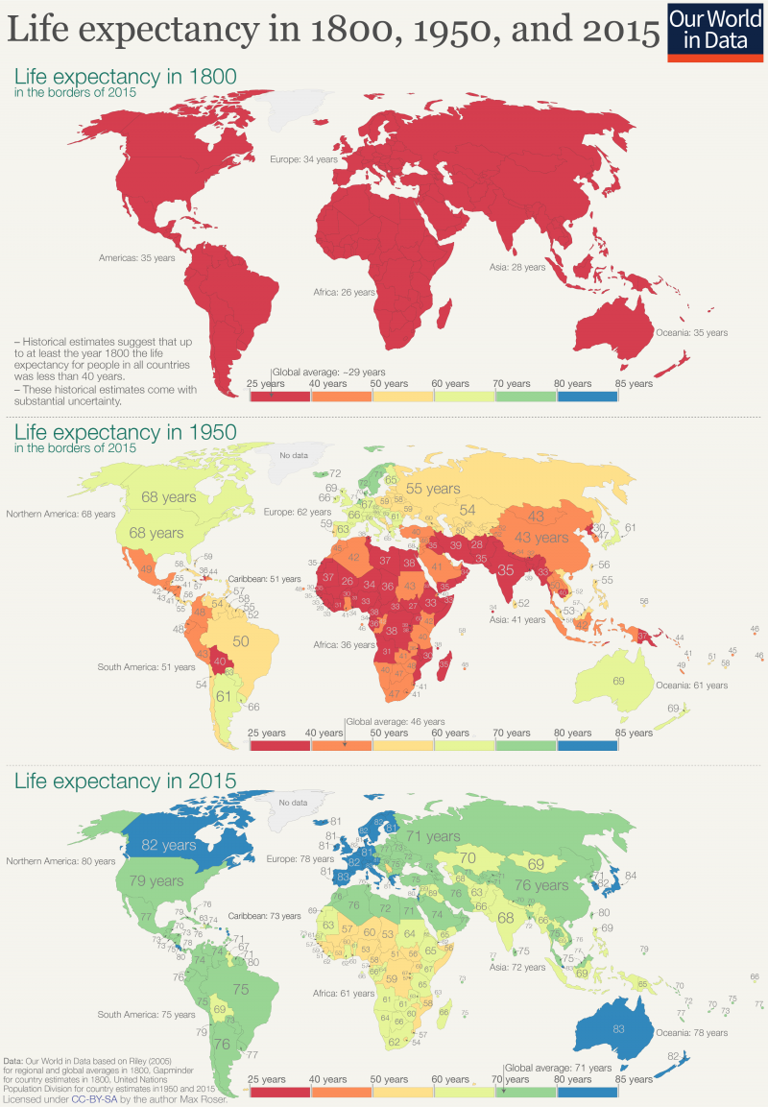

### ***Life expectancy has improved globally***

This visualization shows the dramatic increase in life expectancy over the last few centuries as a line chart. For the UK – the country for which we have the longest time-series – we see that before the 19th century there was no trend for life expectancy: life expectancy fluctuated between 30 and 40 years.

Over the last 200 years people in all countries in the world achieved impressive progress in health that lead to increases in life expectancy. In the UK, life expectancy doubled and is now higher than 80 years. In Japan health started to improve later, but the country caught up quickly with the UK and surpassed it in the late 1960s. In South Korea health started to improve later still and the country achieved even faster progress than the UK and Japan; by now life expectancy in South Korea has surpassed life expectancy in the UK.

The chart also shows how low life expectancy was in some countries in the past: A century ago life expectancy in India and South Korea was as low as 23 years. A century later, life expectancy in India has almost tripled and in South Korea it has almost quadrupled.

You can switch to the map view to compare life expectancy across countries. This view shows that there are still huge differences between countries: people in Sub-Saharan countries have a life expectancy of less than 50 years, while in Japan it exceeds 80.

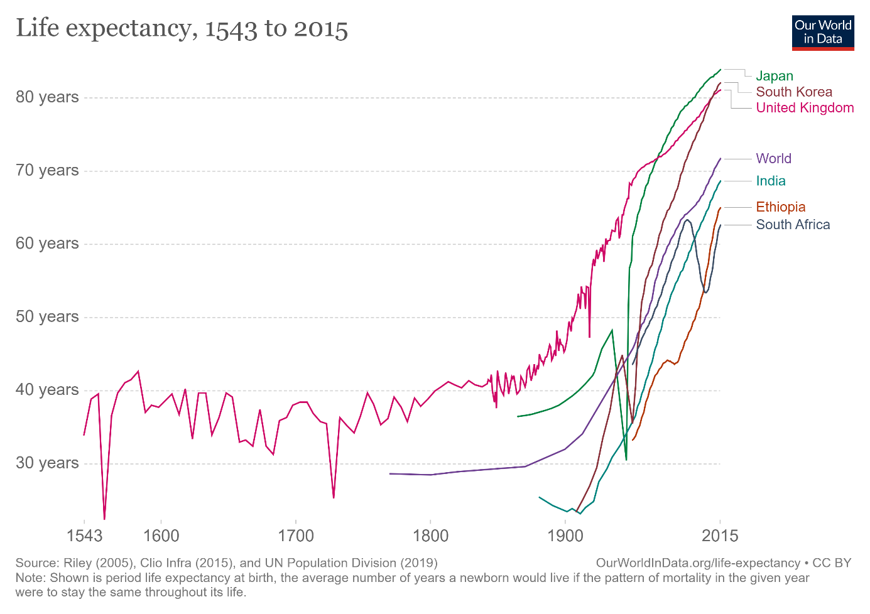

# *****How has healthy life expectancy changed?*****

# 

As prior visualizations in this entry have shown, life expectancy has been rising globally. However, this can be broken down further into ‘healthy life expectancy’ and ‘years lived with disability’. This breakdown in shown in this chart.

It is true that there has been an increase for most countries in both aspects. Healthy life expectancy has increased across the world (in some countries, significantly in recent decades). It is also true that improved healthcare and treatments have also increased the number of years, on average, in which people live with a given disease burden or disability. This increase has, in most cases, been slower than the increase of healthy life expectancy.

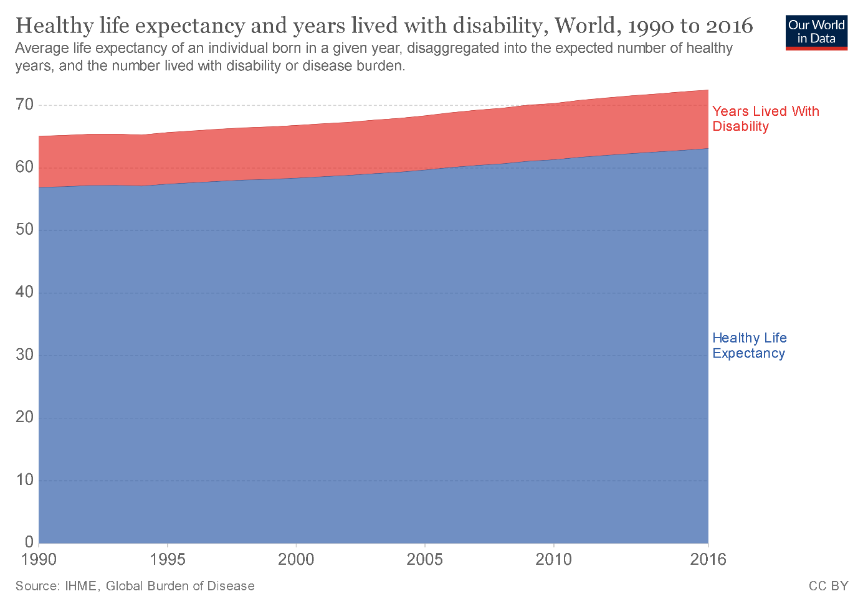

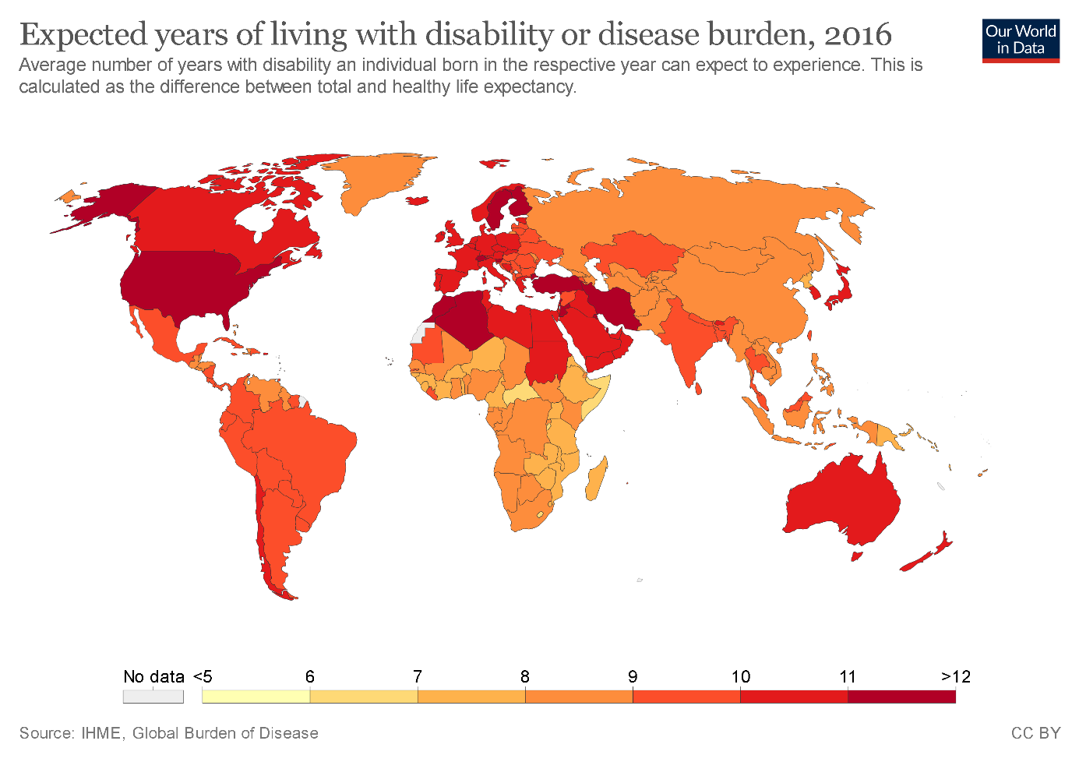

The map shows the expected years lived with disability across the world. In general, we tend to see that higher-income countries tend to spend more years with disability or disease burden than at lower incomes (around 10-11 years versus 7-9 years at lower incomes).

# *****General Looking on Life Expectancy Values Based on Regions and Years*****

**Inequality of life expectancy**

The inequality in years of life between people within the same country can be measured in the same way that we measure, for example, the inequality in the distribution of incomes. The idea is to estimate the extent to which a small share of a country’s population concentrates a large ‘stock of health’, hence living much longer than most of the population in the same country.

The following visualization presents estimates of the inequality of lifetimes as measured by the Gini coefficient. A high Gini coefficient here means a very unequal distribution of years of life – that is, large within-country inequalities of the number of years that people live. These estimates are from Peltzman (2009)

As can be seen in the chart, inequality in health outcomes has fallen strongly within many countries.

# 

# *****What drives improvements in life expectancy?*****

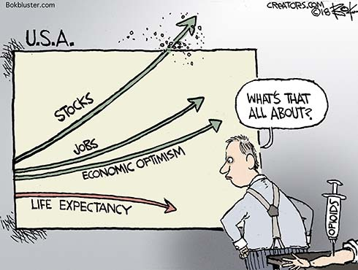

Many aspects had to change for life expectancy to double. It is helpful therefore to read our entries on all the many causes of death, from infectious diseases like [smallpox](https://ourworldindata.org/smallpox) and [malaria](https://ourworldindata.org/malaria) to non-communicable diseases like [cancer](https://ourworldindata.org/cancer). Not just specific medical innovations, like [vaccinations](https://ourworldindata.org/vaccination) or antibiotics, were necessary, but also public health interventions – [improved public sanitation](https://ourworldindata.org/sanitation) and [publicly funded healthcare](https://ourworldindata.org/financing-healthcare) – were crucial.

Below we are looking at several aspects

*How strong is the link between healthcare expenditure and life expectancy?*

One of the most important inputs to health is healthcare. Here we study cross-country evidence of the link between aggregate healthcare consumption and production, and health outcomes.

One common way of measuring national healthcare consumption and production is to estimate aggregate expenditure on healthcare (typically expressed as a share of national income).

This visualization shows the cross-country relationship between life expectancy at birth and healthcare expenditure per capita.

The chart shows the level of both measures at two points in time, about a generation apart (1995 and 2014 respectively). The arrows connect these two observations, thereby showing the change over time of both measures for all countries in the world. As it can be seen, countries with higher expenditure on healthcare per person tend to have a higher life expectancy. And looking at the change over time, we see that as countries spend more on health, life expectancy of the population increases.

Notice that the relationship in this chart seems to follow a pattern of ‘diminishing returns’: the increase in life expectancy associated with an increase in healthcare expenditure decreases as expenditure increases. This means the proportional highest gains are achieved in poor countries with low baseline levels of spending. This pattern is similar to that observed between life expectancy and per capita income.

The countries are color-coded by world region, as per the inserted legends. Many of the green countries (Sub-Saharan Africa) achieved remarkable progress over the last 2 decades: health spending often increased substantially and life expectancy in many African countries increased by more than 10 years. The most extreme case is Rwanda, where life expectancy has increased from 32 to 64 years since 1995 – which was one year after the Rwandan genocide. The graph also shows that the African countries that suffered the most under the HIV/AIDS epidemic – Lesotho, Swaziland, and South Africa – experienced a decline of life expectancy from which they have not yet recovered.

The two most populous countries of the world – India and China – are emphasized by larger arrows. It is interesting to see that in 1995 China achieved already relatively good health outcomes at comparatively low levels of health spending.

The association between health spending and increasing life expectancy also holds for rich countries in Europe, Asia, and North America in the upper right corner of the chart. The US is an outlier that achieves only a comparatively short life expectancy considering the fact that the country has by far the highest health expenditure of any country in the world.

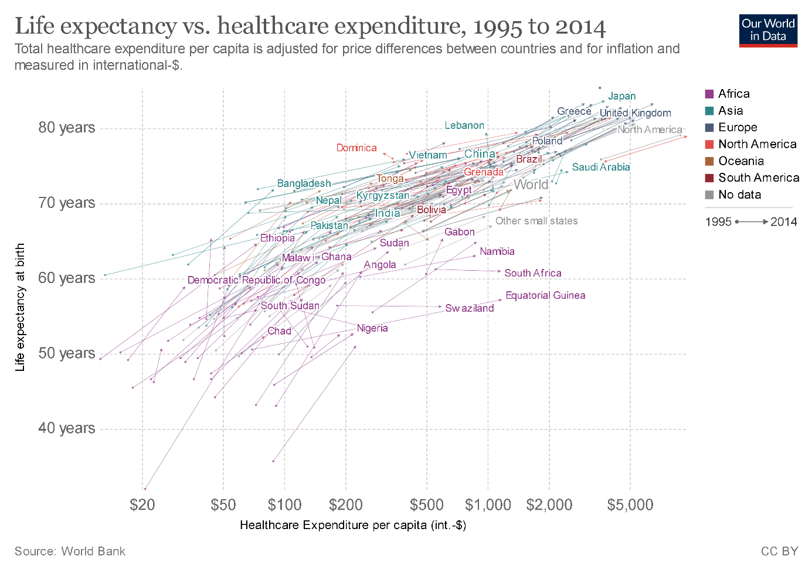

**Years lived with disability vs. healthcare expenditure**

In this chart we see the relationship between years lived with disability or disease burden versus average per capita health expenditure. Here we see a positive correlation whereby countries with higher healthcare expenditure tend to live more years with disability or disease burden. This is likely to result from increased healthcare resourcing in general care and treatment (allowing for an extension of life with a given illness or disability).

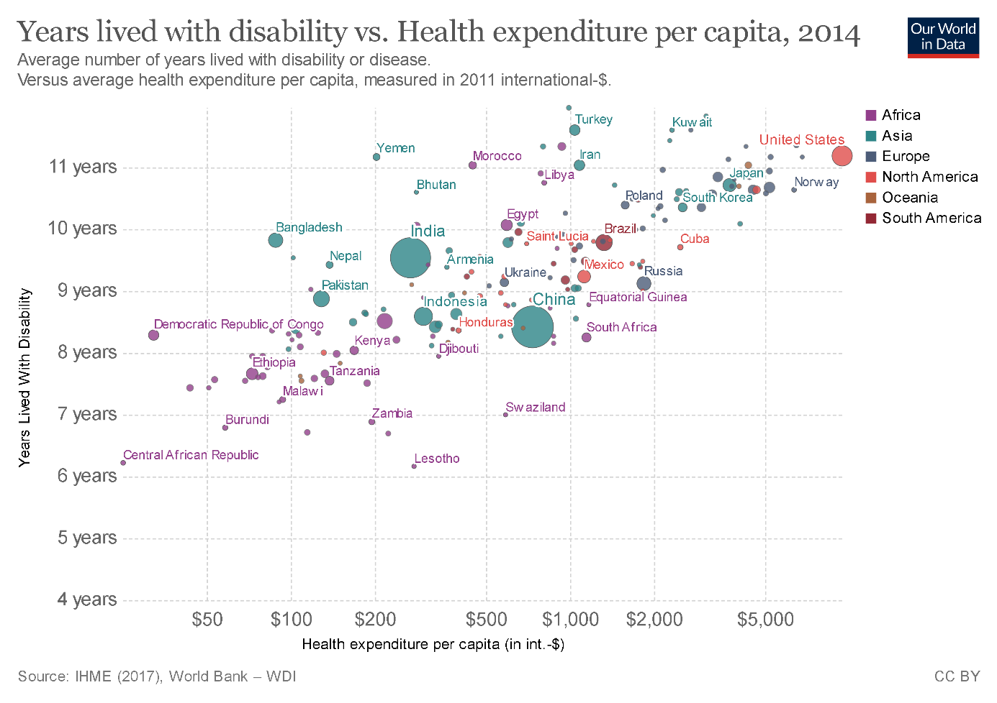

# *Life expectancy and GDP*

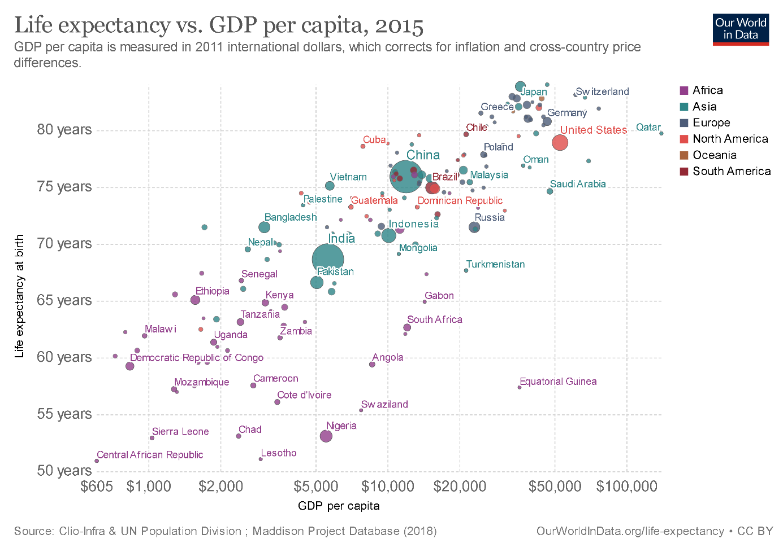

This graph displays the correlation between life expectancy and gross domestic product (GDP) per capita. It shows that In general, countries with higher GDP tend to have a higher life expectancy. It is a logarithmic relationship: the difference in life expectancy per difference in GDP per capita is higher for poorer than for richer countries.

The cross-sectional relationship between life expectancy and per capita income is known as the Preston Curve, named after Samuel H. Preston who first described it in a famous paper from 1975.13

In the chart we are plotting the cross-sectional relationship for the years 1800, 1950, 1980, and 2012. Interestingly we then find that the life expectancy associated with a given level of real income is rising over time. If economic development was the only determinant of health countries then we would see a steady relationship between the two metrics and the curve would not shift over time. Since this is not the case we can conclude that economic development cannot be the sole determinant of health. A possible explanation for this changing relationship is that scientific understanding and technological progress makes some very efficient public health interventions – such as vaccinations, hygiene measures, oral rehydration therapy, and public health measures – cheaper and brings these more and more into the reach of populations with lower and lower incomes.

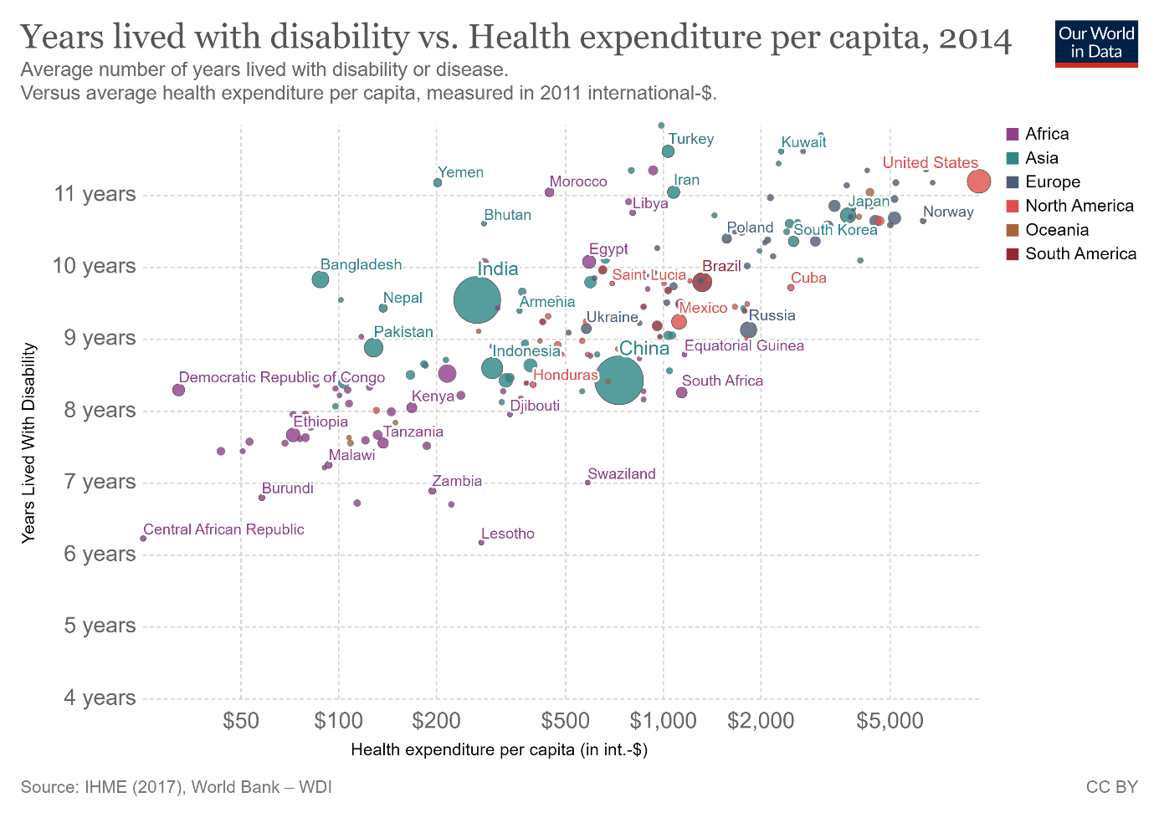

The Preston curves below show the correlation between prosperity and life expectancy across countries. How did life expectancy change over time when countries got richer?

The historical research focuses on England as it is the country that first achieved economic growth and also the country for which we have the best long-run data.

The historical data for life expectancy in England shows clearly that life expectancy did not increase for much of the early period of British industrialization. According to the famous research by historian and Nobel laureate Robert Fogel living conditions for most people declined during the early period of industrialization. The debate about how living conditions changed then is still very much alive today,14 but what is clear however from this research is that rising prosperity itself is not sufficient to improvements in health. This is why my research on this is so very broad and why I explain that “measuring economic growth is not enough” to understand whether we are making progress against the problems we are concerned with.

***LES CONTROLES DE SAISIE***

df['percentage expenditure'].unique()

array([364.9752287 , 428.7490668 , 430.8769785 , ..., 10.66670728,

92.60233636, 63.75053034])

On prendra donc [10-20-…500]

df['Alcohol'].unique()

array([-1.69369222e-01, -1.91149652e-01, -1.30648459e-01, -3.86866441e-02,

1.69744541e-02, -4.80597564e-03, 1.18616459e-01, 7.50556000e-02,

6.77954568e-02, 2.45416761e-03, -3.38465486e-02, -1.83889509e-01,

-2.44390703e-01, -3.79913376e-01, -2.54070894e-01, -3.96853711e-01,

-3.14572087e-01, -1.28017114e+00, -1.15432866e+00, -1.12286803e+00,

-1.14706851e+00, -1.17368904e+00, -1.16158880e+00, -1.17126899e+00,

-1.19546947e+00, -1.22693009e+00, -1.22208999e+00, 7.88969686e-01,

7.93809781e-01, 6.97007871e-01, 6.14726248e-01, 6.09886152e-01,

7.18788301e-01, 8.08330068e-01, 8.78511452e-01, 1.13745656e+00,

6.36506677e-01, 7.21208349e-01, 7.38148683e-01, 6.80067537e-01,

6.89747728e-01, 7.33308587e-01, 6.92167776e-01, 5.92945818e-01,

5.39704768e-01, 5.63905245e-01, 5.61485197e-01, 5.95365866e-01,

5.76005484e-01, -3.36352517e-01, -3.65393090e-01, -3.41192613e-01,

-2.92791658e-01, -2.58910989e-01, -3.24252278e-01, -3.12152040e-01,

-3.60552995e-01, -5.49316719e-01, -5.90457531e-01, 1.06727518e+00,

1.10599594e+00, 1.14471670e+00, 1.21005799e+00, 1.26329904e+00,

1.28749952e+00, 1.32138019e+00, 1.27297924e+00, 1.21247804e+00,

1.09873580e+00, 1.13019642e+00, 1.02371432e+00, 1.69890764e+00,

1.57790525e+00, 1.68438735e+00, 1.63114630e+00, 1.64566659e+00,

1.45206277e+00, 1.62146611e+00, 1.74246850e+00, 1.71826802e+00,

1.66986707e+00, -7.64700968e-01, -8.03421732e-01, -7.74381159e-01,

1.00435394e+00, 9.97093792e-01, 1.01645417e+00, 9.77733410e-01,

9.41432694e-01, 9.65633171e-01, 1.31896014e+00, 1.39640167e+00,

1.25603890e+00, 1.16165704e+00, 1.30201981e+00, 1.34316062e+00,

-9.02643690e-01, -8.83283308e-01, -8.71183069e-01, -8.80863260e-01,

-8.15521971e-01, -8.10681876e-01, -7.98581637e-01, -7.86481398e-01,

-7.59860873e-01, -8.01001685e-01, -7.62280921e-01, 8.51890927e-01,

8.32530545e-01, 8.01069924e-01, 7.76869447e-01, 7.64769208e-01,

8.83351548e-01, 7.67189256e-01, 7.47828874e-01, 6.55867059e-01,

5.15504290e-01, 2.09095537e+00, 2.26519881e+00, 2.67418688e+00,

2.90651146e+00, 2.21195776e+00, 2.12725609e+00, 2.26761886e+00,

1.76666898e+00, 1.38188138e+00, 1.63356635e+00, 1.67712721e+00,

1.31654009e+00, 1.56580501e+00, 1.15681694e+00, 1.16407709e+00,

1.19069761e+00, 1.14955680e+00, 1.25119881e+00, 1.19795775e+00,

1.37462124e+00, 1.68680740e+00, 3.09800232e-01, 3.04960136e-01,

3.29160614e-01, 3.24320518e-01, 3.53361091e-01, 3.75141521e-01,

4.64683287e-01, 4.69523383e-01, 2.85599754e-01, 2.29938656e-01,

2.17838417e-01, 8.95758865e-02, -7.49873603e-02, -9.67677900e-02,

-1.23388315e-01, -9.43784502e-01, -9.60724836e-01, -9.72825075e-01,

-1.01154584e+00, -9.94605504e-01, -1.00428570e+00, -9.55884740e-01,

-4.06533902e-01, -3.67813138e-01, -3.31512422e-01, -3.46032708e-01,

-3.70233186e-01, -4.42834618e-01, -5.00915764e-01, -6.38858485e-01,

-7.35660395e-01, -7.50180682e-01, -7.21140109e-01, -3.07311944e-01,

-2.85531514e-01, -1.66949175e-01, -1.59689031e-01, -4.11066918e-02,

1.11356316e-01, 1.67017414e-01, -7.01472648e-02, 2.20258465e-01,

2.78339611e-01, 4.88883765e-01, 5.44544863e-01, 5.51805006e-01,

5.37284720e-01, 4.91303813e-01, 4.62263240e-01, 4.57423144e-01,

4.35642714e-01, 4.04182094e-01, -1.04784655e+00, -1.06962698e+00,

-1.12044799e+00, -1.07688713e+00, -1.24387042e+00, -1.25597066e+00,

-1.25355061e+00, -1.25113057e+00, -1.16884894e+00, -1.19304942e+00,

1.62872625e+00, 1.63598640e+00, 1.37704129e+00, 1.29959976e+00,

1.36252100e+00, 1.35284081e+00, 1.23183842e+00, 1.25361885e+00,

1.36978114e+00, 1.42544224e+00, 1.18585752e+00, 1.31170000e+00,

1.06243508e+00, -5.56576862e-01, -2.75851323e-01, -3.02471849e-01,

-2.34710512e-01, -1.62647786e-01, -4.98495716e-01, -5.20276146e-01,

-5.75937244e-01, -6.58218867e-01, -6.41278533e-01, -5.29956337e-01,

-1.33068506e-01, -2.05669939e-01, -2.51650846e-01, -2.68591180e-01,

-7.69541064e-01, -7.67121016e-01, -7.40500491e-01, -7.79221255e-01,

-9.48624597e-01, 2.05738178e-01, 1.45236985e-01, 3.39147883e-02,

-1.93262621e-02, 5.80845579e-01, 5.56645102e-01, 4.50163001e-01,

4.74363478e-01, 5.73585436e-01, 4.86463717e-01, 5.05824099e-01,

5.49384959e-01, 2.46878990e-01, 2.58979229e-01, 1.83957749e-01,

1.93637940e-01, 2.27518608e-01, -2.15350130e-01, -2.08089986e-01,

-2.25030321e-01, -2.46810750e-01, -2.32290464e-01, -1.54848936e-01,

-1.86309557e-01, -2.22610273e-01, -1.24629047e+00, -1.24145037e+00,

-4.28314331e-01, -4.47674713e-01, -4.54934857e-01, -4.57354904e-01,

-4.16214093e-01, -2.66171132e-01, -2.78271371e-01, -3.04891896e-01,

-2.73431276e-01, 1.65534678e+00, 1.71584797e+00, 1.49804368e+00,

1.66744702e+00, 1.67228711e+00, 1.75698878e+00, 1.58032530e+00,

1.52224415e+00, 1.89009141e+00, 2.05223461e+00, 1.95785275e+00,

1.89977160e+00, 1.79812960e+00, -2.71011228e-01, -2.80691419e-01,

-2.83111467e-01, -1.98409795e-01, -2.20190225e-01, -2.90371610e-01,

-3.33932469e-01, 9.05131977e-01, 1.27055919e+00, 1.30443986e+00,

1.45690286e+00, 1.33106038e+00, 1.62388616e+00, 1.51498401e+00,

1.49320358e+00, 1.47868329e+00, 1.87073103e+00, 1.54402458e+00,

1.17617733e+00, 1.03097446e+00, 1.78602936e+00, 1.73036826e+00,

1.79328950e+00, 1.72552816e+00, 1.78844941e+00, 1.91913198e+00,

1.92397208e+00, 1.96753294e+00, 1.90945179e+00, 1.92155203e+00,

1.86589093e+00, 1.97721313e+00, 1.95059260e+00, 1.91671194e+00,

-4.71875191e-01, -4.08953949e-01, -4.62195000e-01, -5.27536289e-01,

-5.17856098e-01, -5.25116241e-01, -4.88815525e-01, -5.05755859e-01,

1.05033484e+00, 9.58373028e-01, 1.30685990e+00, 1.38430143e+00,

1.44722267e+00, 1.44480263e+00, 1.51014391e+00, 1.46174296e+00,

1.54644463e+00, 1.52497128e-01, 1.74277558e-01, 1.98478035e-01,

1.81537701e-01, 9.92560775e-02, -3.58132947e-01, -3.16992135e-01,

-3.72653233e-01, -4.04113854e-01, -4.30734379e-01, -4.25894284e-01,

-3.89593567e-01, -3.43612660e-01, -1.23177018e+00, -1.22935014e+00,

-1.22451004e+00, -1.23903033e+00, -1.24871052e+00, -6.72739154e-01,

-6.96939631e-01, -6.82419345e-01, -7.11459918e-01, -6.65479011e-01,

-6.34018390e-01, -5.97717674e-01, -6.12237960e-01, -5.32376385e-01,

-5.63837005e-01, -5.85617435e-01, -6.07397865e-01, 2.34022029e+00,

2.35716063e+00, 2.82906994e+00, 2.72984798e+00, 2.47332292e+00,

1.53434439e+00, 1.49562363e+00, -7.38080443e-01, -7.23560157e-01,

-7.76801207e-01, -7.84061350e-01, -7.93741541e-01, -8.88123403e-01,

-8.56662783e-01, -8.34882353e-01, 8.47050831e-01, 8.88191643e-01,

9.53532932e-01, 1.09147565e+00, 1.06969522e+00, 1.12777637e+00,

1.20037780e+00, 1.24635871e+00, 1.17375728e+00, 1.12535632e+00,

1.11083604e+00, 9.70473267e-01, 9.55952980e-01, 8.80931500e-01,

7.96229829e-01, 1.50046372e+00, 1.40366181e+00, 8.61571118e-01,

8.71251309e-01, 8.34950593e-01, 9.00291882e-01, -4.40414570e-01,

-5.58996910e-01, -6.43698581e-01, -5.73517196e-01, -6.75159202e-01,

-6.84839393e-01, 2.00898083e-01, 1.47657032e-01, 5.83265627e-01,

6.87327680e-01, 8.10750115e-01, 2.12998322e-01, -1.45168745e-01,

1.38672148e+00, 1.36494105e+00, 1.42302220e+00, 1.42786229e+00,

1.43270239e+00, 1.46658305e+00, 1.56338496e+00, 1.68196730e+00,

1.73278831e+00, -8.85703356e-01, -8.73603117e-01, -8.51822687e-01,

-9.80085218e-01, -9.19584024e-01, 5.22764433e-01, 7.01847967e-01,

6.58287107e-01, 8.95451786e-01, 9.14812168e-01, 1.01887422e+00,

1.05759499e+00, 1.00677398e+00, 6.75227441e-01, 7.69609304e-01,

7.55089017e-01, 7.13948205e-01, 6.70387346e-01, -7.47760634e-01,

-7.01779727e-01, -7.13879966e-01, -6.89679488e-01, -6.99359679e-01,

-4.18634140e-01, 5.66325293e-01, 5.46964911e-01, 5.30024577e-01,

4.59843192e-01, 4.21122428e-01, 4.96143908e-01, 5.88105722e-01,

3.21900470e-01, -5.88037483e-01, -5.37216480e-01, -5.22696194e-01,

-5.51736767e-01, -5.46896671e-01, -5.34796432e-01, -6.19498103e-01,

-6.50958724e-01, 1.35042076e+00, 1.50288377e+00, 1.32622029e+00,

1.49078353e+00, 1.75456874e+00, 1.90219165e+00, 1.84895060e+00,

1.93123222e+00, 1.93365227e+00, 1.90703174e+00, 1.67470716e+00,

6.07466104e-01, 6.84907632e-01, 7.72029351e-01, 4.23542476e-01,

3.60621234e-01, 3.17060375e-01, 2.10578274e-01, -1.27533104e+00,

-1.27775109e+00, -1.23661028e+00, 1.55370477e+00, 1.78118926e+00,

2.00625370e+00, 1.96995299e+00, 1.94091241e+00, 2.14661647e+00,

2.17081695e+00, 2.12241599e+00, -6.48538676e-01, -6.31598342e-01,

-6.09817912e-01, -6.36438438e-01, -6.46118629e-01, -7.18720061e-01,

-7.42920539e-01, -6.70319106e-01, 4.06602141e-01, 3.99341998e-01,

4.71943431e-01, 6.43766821e-01, 7.42988778e-01, 7.59929113e-01,

8.90611691e-01, 1.08421551e+00, -3.55712899e-01, -3.99273758e-01,

-4.23474236e-01, -4.33154427e-01, -4.01693806e-01, -4.13794045e-01,

-3.94433663e-01, -4.45254666e-01, 3.87241759e-01, 4.33222667e-01,

4.81623622e-01, 6.51026964e-01, 6.12306200e-01, -1.18336923e+00,

-1.18578928e+00, -1.17852913e+00, -1.15916875e+00, -1.13980837e+00,

-1.13496827e+00, -1.13738832e+00, -1.14948856e+00, -1.15190861e+00,

-1.16400885e+00, 2.39618847e-01, 3.67881377e-01, 3.70301425e-01,

5.17924338e-01, 4.30802619e-01, 3.02540088e-01, 1.08936268e-01,

1.69437462e-01, -8.37302401e-01, -8.44562544e-01, -8.46982592e-01,

-8.32462305e-01, -8.68763021e-01, -1.16642889e+00, -1.11802794e+00,

-1.09866756e+00, -1.25839071e+00, -6.21918151e-01, -7.04199775e-01,

-6.02557769e-01, -4.81555382e-01, 2.18145496e-02, 1.57337223e-01,

1.22699833e+00, 1.17133723e+00, 1.08905561e+00, 1.10115584e+00,

1.58274535e+00, 1.65050668e+00, 1.23425847e+00, 1.11809618e+00,

8.49470879e-01, 7.11528158e-01, 3.34000709e-01, 4.42902858e-01,

-9.63144884e-01, -9.70405027e-01, -9.12323881e-01, -9.00223642e-01,

-8.90543451e-01, -8.78443212e-01, -8.42142496e-01, -6.26758247e-01,

-3.82333424e-01, 2.39346134e+00, 2.38136110e+00, 1.83927041e+00,

1.93607232e+00, 1.96027280e+00, 1.79086945e+00, 1.69406754e+00,

1.44964272e+00, 1.37946134e+00, 1.48110334e+00, 1.56096492e+00,

1.72310812e+00, 1.76908902e+00, 1.84169046e+00, 1.83685036e+00,

1.89735155e+00, -1.07204703e+00, -1.06236684e+00, -1.11076780e+00,

-9.84925313e-01, -1.00186565e+00, -1.15674870e+00, -1.18094918e+00,

-8.17942019e-01, -8.39722449e-01, -8.97803594e-01, -9.26844167e-01,

-8.95383547e-01, -8.59082830e-01, 3.89661807e-01, 6.31666582e-01,

5.03404051e-01, 4.45322905e-01, 5.20344386e-01, 8.56731022e-01,

2.68659420e-01, 2.97699993e-01, 3.38840804e-01, 1.04096173e-01,

7.74756478e-02, 7.02155045e-02, -5.68677101e-01, -6.79999297e-01,

-3.29092374e-01, -2.95211705e-01, -9.64607113e-03, -1.69062144e-02,

-2.38592789e-03, 3.41198578e-05, -2.17463099e-02, -7.22602338e-03,

1.45544063e-02, 1.21343586e-02, -4.59467873e-02, -8.95076468e-02,

-1.01607886e-01, -1.28228411e-01, -1.06447981e-01, -5.61416958e-01,

-8.25202162e-01, -8.05841780e-01, -8.63922926e-01, -8.22782114e-01,

-6.00137722e-01, 1.21036507e-01, -5.78357292e-01, -6.17078056e-01,

-9.65564931e-01, -6.94519584e-01, -1.13254823e+00, -1.14222842e+00,

-1.05510670e+00, -1.05026660e+00, -1.11318784e+00, -1.20998975e+00,

-1.21966994e+00, -1.21482985e+00, 2.37198799e-01, -1.21724990e+00,

-1.23419023e+00, 9.75313362e-01, 9.51112885e-01, 1.04549475e+00,

1.08663556e+00, 1.06001503e+00, 1.15197685e+00, 8.22850354e-01,

9.12392121e-01, 9.39012646e-01, 9.43852741e-01, 1.00919403e+00,

9.31752503e-01, -4.64615048e-01, -4.69455143e-01, -3.87173520e-01,

-4.35574475e-01, 1.62177319e-01, 3.50941043e-01, 2.22678513e-01,

1.79117653e-01, 1.42816937e-01, 4.60150271e-02, -1.14464846e+00,

-1.13012818e+00, 3.96921950e-01, 3.79981616e-01, 3.48520995e-01,

2.08158226e-01, 1.01676125e-01, 5.56952180e-02, 9.44159820e-02,

5.32751703e-02, 3.14947406e-02, 8.47357910e-02, 2.03318131e-01,

2.61399277e-01, 8.71558388e-02, 3.58201186e-01, 1.93945018e-02,

-1.13708124e-01, -1.40328649e-01, -1.47588793e-01, -1.08868029e-01,

-2.61331037e-01, -2.49230798e-01, -1.71789270e-01, -6.77272171e-02,

-8.22475036e-02, -2.12930082e-01, -2.63751085e-01, 1.30927995e+00,

1.53192434e+00, 1.33348043e+00, 1.28023938e+00, 1.47626325e+00,

1.35526086e+00, 9.09972073e-01, 5.90525770e-01, 7.50248922e-01,

1.10841599e+00, 1.61178592e+00, 1.60210573e+00, 1.70616778e+00,

1.75940883e+00, 1.94333246e+00, 1.97237303e+00, 2.15629666e+00,

-9.92185457e-01, -1.00912579e+00, -1.01396589e+00, -9.51044645e-01,

-9.82505266e-01, -9.97025552e-01, -1.04058641e+00, 9.07552025e-01,

8.54310975e-01, 9.02711930e-01, 1.05517494e+00, 1.02855441e+00,

7.62349160e-01, 7.40568731e-01, 3.41260852e-01, 1.03823460e+00,

1.03581456e+00, 9.19652264e-01, 1.59726563e+00, 1.28265943e+00,

1.09389570e+00, 8.42210736e-01, 1.16649713e+00, 1.27781933e+00,

1.38914153e+00, 1.39156157e+00, 1.43028234e+00, 1.57064511e+00,

1.51740406e+00, 1.34800072e+00, 1.18101742e+00, 7.35728635e-01,

6.34086630e-01, 4.38062762e-01, 2.63819324e-01, 3.82401664e-01,

4.13862285e-01, 7.84129590e-01, 1.07211527e+00, 1.13503651e+00,

1.24151861e+00, 1.40124177e+00, 1.64324654e+00, 1.60452578e+00,

4.28382571e-01, 3.94501903e-01, 4.16282332e-01, 4.11442237e-01,

3.92081855e-01, 2.90746928e-02, -8.70875991e-02, -1.37908602e-01,

-4.83975430e-01, -4.52514809e-01, -2.27450368e-01, 3.87548838e-02,

-5.56269783e-02, -1.26081076e+00, -1.26323080e+00, -1.27049095e+00,

-1.26807090e+00, -1.20514966e+00, 9.17232216e-01, 9.34172550e-01,

9.87413601e-01, 1.05275489e+00, 1.02613436e+00, 9.68053219e-01,

5.13084242e-01, 2.92859897e-01, 2.49299038e-01, 6.82487585e-01,

5.10664195e-01, 1.41576205e+00, 3.43680900e-01, -3.53292851e-01,

-3.21832231e-01, -8.49402639e-01, -9.07483785e-01, -9.22004072e-01,

-9.31684263e-01, -9.36524358e-01, -7.91321494e-01, 1.19553771e+00,

1.16891718e+00, 1.28991957e+00, 1.46900310e+00, 1.20521790e+00,

1.31412005e+00, 1.39398162e+00, 1.24877876e+00, 1.36736110e+00,

1.28507947e+00, 1.21489809e+00, 1.41334200e+00, 1.51982411e+00,

-1.04300646e+00, -9.89765409e-01, -1.01880598e+00, -1.02122603e+00,

9.80153458e-01, 1.58758544e+00, 1.10357589e+00, 1.40850191e+00,

-7.09039870e-01, -6.63058963e-01, -6.04977817e-01, -7.28400252e-01,

-8.08261828e-01, -8.76023165e-01, -6.77579249e-01, 8.23157433e-02,

-1.88729604e-01, -2.00829843e-01, 4.84043669e-01, 2.90439850e-01,

3.14640327e-01, 1.13987661e+00, 1.20763795e+00, 1.24393866e+00,

1.33590048e+00, 1.44238258e+00, -1.08898737e+00, -1.05752675e+00,

-9.41364454e-01, -1.19788952e+00, -1.19062937e+00, -1.07446708e+00,

1.86377796e-01, 1.40396889e-01, 1.50077080e-01, 2.32358704e-01,

-1.03332627e+00, -8.54242735e-01, -8.66342974e-01, -8.61502878e-01,

-9.34104311e-01, -1.01638593e+00, -9.17163976e-01, 2.54139133e-01,

1.25876603e-01, -1.81469461e-01, -9.46204549e-01, -9.67984979e-01,

-9.29264215e-01, -9.53464693e-01, -9.58304788e-01, -9.99445600e-01,

-9.09903833e-01, -9.77665170e-01, -5.80777340e-01, -8.20362067e-01,

1.29717971e+00, 1.23909857e+00, 1.32864033e+00, 1.52708425e+00,

1.58516539e+00, 1.48594344e+00, 1.35768091e+00, 1.76697605e-01,

1.13776364e-01, 3.31580661e-01, 1.35556794e-01, 2.83179706e-01,

5.54225054e-01, 2.42038895e-01, -3.48452756e-01, -6.29178294e-01,

-7.52600730e-01, -1.27291100e+00, -7.25980204e-01, 1.91217892e-01])

On prendra donc [-10 ;10]

Aussi pour df['Adult Mortality'].unique()

On prendra le mémé intervalle entre [-10 ;10]

df['Schooling'].unique()

array([14.2, 13.3, 12.5, 12.2, 12. , 11.6, 11.4, 10.8, 10.9, 10.7, 10.6,

14.4, 14. , 13.6, 13.1, 12.6, 11.7, 11.1, 13.9, 13.8, 14.1, 14.5,

14.7, 17.3, 17.2, 17.1, 16.8, 16.5, 16.3, 16.1, 16.4, 15.6, 15. ,

12.7, 12.3, 11.9, 11.2, 20.4, 20.3, 20.1, 19.8, 19.5, 19.1, 19. ,

20.7, 20.6, 20.5, 15.9, 15.7, 15.4, 15.3, 15.1, 15.2, 14.9, 11.8,

12.4, 12.1, 13.7, 13.5, 13.2, 15.5, 14.8, 14.6, 16.6, 16.2, 15.8,

12.8, 12.9, 10.3, 9.8, 9.5, 9.1, 8.9, 8.7, 8.1, 7.7, 14.3,

13.4, 7.5, 10.5, 9.9, 9.3, 8.6, 7.9, 7.2, 8.2, 10. , 9.7,

10.4, 8.8, 8. , 13. , 11.5, 11.3, 10.2, 17.6, 17.7, 16. , 19.2,

18.7, 18.4, 16.9, 16.7, 11. , 17. , 18.3, 18.1, 18. , 8.4, 7.8,

7.6, 7.3, 10.1, 9.6, 9. , 9.2, 18.6, 18.2, 17.9, 18.5, 9.4,

7.1, 8.5, 7.4, 19.3, 19.7, 18.9, 17.5, 17.4, 8.3])

On prendra donc [7 ;21]

df.GDP.unique()

array([3954.22783 , 4575.763787, 4414.72314 , ..., 111.227396,

955.648466, 839.927936]

On prendra donc [100 ;5000]

df.Status.unique()

array([1, 0])

df['Income composition of resources'].unique()

array([0.762, 0.761, 0.759, 0.752, 0.738, 0.725, 0.721, 0.713, 0.703,

0.696, 0.685, 0.681, 0.674, 0.67 , 0.662, 0.656, 0.743, 0.741,

0.737, 0.732, 0.724, 0.714, 0.705, 0.697, 0.68 , 0.673, 0.653,

0.644, 0.636, 0.784, 0.782, 0.781, 0.778, 0.783, 0.788, 0.786,

0.773, 0.826, 0.825, 0.823, 0.822, 0.816, 0.802, 0.794, 0.78 ,

0.775, 0.77 , 0.771, 0.764, 0.739, 0.736, 0.729, 0.72 , 0.692,

0.668, 0.657, 0.645, 0.937, 0.936, 0.933, 0.93 , 0.927, 0.925,

0.921, 0.918, 0.915, 0.91 , 0.908, 0.905, 0.902, 0.899, 0.892,

0.887, 0.884, 0.88 , 0.872, 0.87 , 0.864, 0.86 , 0.854, 0.848,

0.841, 0.837, 0.847, 0.758, 0.745, 0.742, 0.728, 0.79 , 0.789,

0.791, 0.82 , 0.815, 0.812, 0.81 , 0.814, 0.813, 0.806, 0.803,

0.798, 0.796, 0.793, 0.792, 0.785, 0.779, 0.766, 0.757, 0.787,

0.755, 0.723, 0.687, 0.895, 0.89 , 0.889, 0.886, 0.878, 0.876,

0.874, 0.871, 0.865, 0.861, 0.706, 0.702, 0.7 , 0.699, 0.695,

0.691, 0.684, 0.678, 0.677, 0.481, 0.475, 0.466, 0.454, 0.451,

0.444, 0.438, 0.434, 0.423, 0.416, 0.604, 0.596, 0.589, 0.581,

0.572, 0.671, 0.666, 0.661, 0.655, 0.649, 0.632, 0.626, 0.625,

0.622, 0.62 , 0.61 , 0.607, 0.6 , 0.747, 0.735, 0.711, 0.71 ,

0.698, 0.693, 0.669, 0.646, 0.63 , 0.754, 0.734, 0.73 , 0.716,

0.704, 0.694, 0.863, 0.852, 0.846, 0.845, 0.84 , 0.834, 0.828,

0.819, 0.818, 0.768, 0.75 , 0.709, 0.399, 0.398, 0.392, 0.406,

0.404, 0.393, 0.385, 0.361, 0.336, 0.319, 0.309, 0.402, 0.42 ,

0.643, 0.627, 0.621, 0.615, 0.602, 0.582, 0.574, 0.558, 0.553,

0.54 , 0.533, 0.519, 0.52 , 0.511, 0.495, 0.47 , 0.458, 0.514,

0.507, 0.501, 0.496, 0.48 , 0.456, 0.867, 0.804, 0.797, 0.712,

0.707, 0.683, 0.675, 0.658, 0.659, 0.65 , 0.498, 0.497, 0.49 ,

0.484, 0.479, 0.476, 0.465, 0.461, 0.459, 0.576, 0.548, 0.545,

0.527, 0.749, 0.727, 0.715, 0.817, 0.808, 0.8 , 0.777, 0.765,

0.772, 0.719, 0.686, 0.679, 0.85 , 0.853, 0.849, 0.844, 0.836,

0.829, 0.805, 0.923, 0.926, 0.924, 0.922, 0.906, 0.904, 0.897,

0.893, 0.882, 0.875, 0.862, 0.718, 0.717, 0.688, 0.665, 0.651,

0.629, 0.623, 0.617, 0.612, 0.606, 0.676, 0.628, 0.856, 0.838,

0.833, 0.835, 0.689, 0.873, 0.869, 0.866, 0.894, 0.885, 0.664,

0.652, 0.45 , 0.449, 0.445, 0.44 , 0.441, 0.439, 0.426, 0.415,

0.412, 0.395, 0.722, 0.92 , 0.919, 0.916, 0.912, 0.907, 0.903,

0.898, 0.877, 0.575, 0.563, 0.554, 0.547, 0.542, 0.53 , 0.51 ,

0.499, 0.858, 0.859, 0.857, 0.855, 0.839, 0.83 , 0.811, 0.751,

0.746, 0.744, 0.611, 0.616, 0.609, 0.578, 0.567, 0.564, 0.56 ,

0.421, 0.419, 0.41 , 0.405, 0.638, 0.633, 0.624, 0.618, 0.619,

0.613, 0.614, 0.603, 0.597, 0.59 , 0.583, 0.577, 0.571, 0.566,

0.561, 0.557, 0.551, 0.824, 0.821, 0.809, 0.795, 0.769, 0.901,

0.879, 0.774, 0.909, 0.896, 0.891, 0.883, 0.881, 0.868, 0.851,

0.69 , 0.682, 0.733, 0.763, 0.55 , 0.546, 0.541, 0.536, 0.506,

0.585, 0.584, 0.799, 0.647, 0.631, 0.601, 0.573, 0.535, 0.807,

0.776, 0.74 , 0.469, 0.464, 0.756, 0.748, 0.888, 0.509, 0.508,

0.504, 0.5 , 0.491, 0.483, 0.478, 0.473, 0.731, 0.701, 0.663,

0.641, 0.587, 0.43 , 0.396, 0.487, 0.667, 0.753, 0.708, 0.637,

0.639, 0.64 , 0.608, 0.599, 0.634, 0.569, 0.409, 0.4 , 0.397,

0.39 , 0.552, 0.493, 0.474, 0.598, 0.529, 0.515, 0.502, 0.492,

0.486, 0.913, 0.642, 0.592, 0.57 , 0.562, 0.948, 0.945, 0.942,

0.941, 0.939, 0.929, 0.917, 0.654, 0.648, 0.827, 0.843, 0.488,

0.485, 0.447, 0.424, 0.388, 0.371, 0.359, 0.343, 0.565, 0.559,

0.531, 0.521, 0.767, 0.463, 0.455, 0.435, 0.431, 0.413, 0.401,

0.384, 0.375, 0.367, 0.911, 0.842, 0.512, 0.505, 0.494, 0.489,

0.453, 0.446, 0.76 , 0.672, 0.539, 0.534, 0.938, 0.914, 0.588,

0.586, 0.579, 0.457, 0.442, 0.443, 0.436, 0.832, 0.831, 0.594,

0.477, 0.518, 0.452])

Donc [0.1-0.2-0.3-…….1]

***About the data set***



**Variable Descriptions**

\**Format: variable (type) - description \**

**country** *(Nominal) *- the country in which the indicators are from (i.e. United States of America or Congo)

**year** *(Ordinal)*- the calendar year the indicators are from (ranging from 2000 to 2015)

**status** *(Nominal)* - whether a country is considered to be 'Developing' or 'Developed' by WHO standards

**life_expectancy** *(Ratio)* - the life expectancy of people in years for a particular country and year

**adult_mortality** *(Ratio)* - the adult mortality rate per 1000 population (i.e. number of people dying between 15 and 60 years per 1000 population); if the rate is 263 then that means 263 people will die out of 1000 between the ages of 15 and 60; another way to think of this is that the chance an individual will die between 15 and 60 is 26.3%

**infant_deaths** *(Ratio)* - number of infant deaths per 1000 population; similar to above, but for infants

**alcohol** *(Ratio)* - a country's alcohol consumption rate measured as liters of pure alcohol consumption per capita

**percentage_expenditure** *(Ratio)* - expenditure on health as a percentage of Gross Domestic Product (gdp)

**hepatitis_b** *(Ratio)* - number of 1 year olds with Hepatitis B immunization over all 1 year olds in population

**measles** *(Ratio)* - number of reported Measles cases per 1000 population

**bmi** *(Interval/Ordinal)* - average Body Mass Index (BMI) of a country's total population

**under-five_deaths** *(Ratio)* - number of people under the age of five deaths per 1000 population

**polio** *(Ratio)* - number of 1 year olds with Polio immunization over the number of all 1 year olds in population

**total_expenditure** *(Ratio)* - government expenditure on health as a percentage of total government expenditure

**diphtheria** *(Ratio)* - Diphtheria tetanus toxoid and pertussis (DTP3) immunization rate of 1 year olds

**hiv/aids** *(Ratio)* - deaths per 1000 live births caused by HIV/AIDS for people under 5; number of people under 5 who die due to HIV/AIDS per 1000 births **gdp** *(Ratio)* - Gross Domestic Product per capita

**population** *(Ratio)* - population of a country

**thinness_1-19_years** *(Ratio)* - rate of thinness among people aged 10-19

(Note: variable should be renamed to thinness_10-19_years to more accurately represent the variable)

**thinness_5-9_years** *(Ratio)* - rate of thinness among people aged 5-9

**income_composition_of_resources** *(Ratio)* - Human Development Index in terms of income composition of resources (index ranging from 0 to 1)

**schooling** *(Ratio)* - average number of years of schooling of a population